**EXP:6 Moving Average Smoothing for Time Series Forecasting**

**AIM:** To implement a program that applies moving average smoothing to weather data for data preparation and time series forecasting.

**INTRODUCTION:** Moving average smoothing is a statistical technique used in time series analysis to smooth out short-term fluctuations and highlight longer-term trends. It is widely used for data preparation and forecasting applications. This experiment applies different moving average window sizes to a weather dataset and visualizes the smoothed trends.

**PROCEDURE:**

**Step 1: Load Required Libraries**

import pandas as pd

import matplotlib.pyplot as plt

**Step 2: Load the Weather Dataset**

file_path = "/content/weather.csv" # Path to dataset

# Load dataset into a Pandas DataFrame

df = pd.read_csv(file_path)

# Display first few rows to understand structure

display(df.head())

**Step 3: Preprocess the Data**

# Convert date column to datetime format

df['Date.Full'] = pd.to_datetime(df['Date.Full'])

# Sort values by date

df = df.sort_values(by='Date.Full')

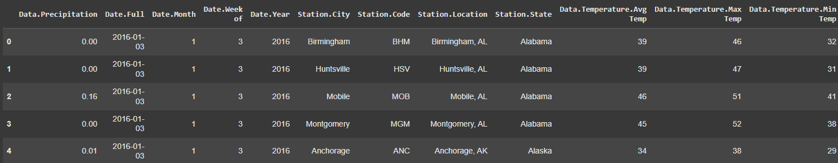

**Step 4: Apply Moving Average Smoothing**

# Apply moving averages with different window sizes

df['MA_3'] = df['Data.Temperature.Avg Temp'].rolling(window=3).mean()

df['MA_5'] = df['Data.Temperature.Avg Temp'].rolling(window=5).mean()

df['MA_7'] = df['Data.Temperature.Avg Temp'].rolling(window=7).mean()

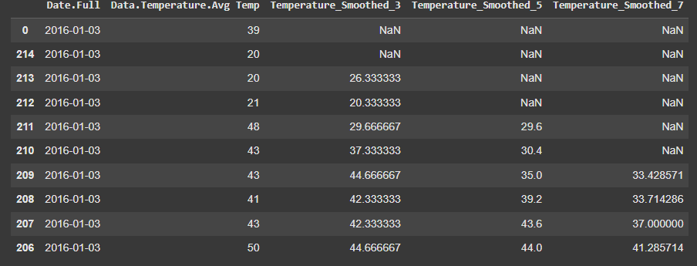

**Step 5: Visualize the Results**

plt.figure(figsize=(12, 6))

plt.plot(df['Date.Full'], df['Data.Temperature.Avg Temp'], label='Original Temperature', alpha=0.5)

plt.plot(df['Date.Full'], df['MA_3'], label='3-Day Moving Average', color='green')

plt.plot(df['Date.Full'], df['MA_5'], label='5-Day Moving Average', color='blue')

plt.plot(df['Date.Full'], df['MA_7'], label='7-Day Moving Average', color='red')

plt.xlabel('Date')

plt.ylabel('Temperature')

plt.title('Temperature Trend with Moving Averages')

plt.legend()

plt.show()

